# Lesson 58 单词讲解

1. blessing n. 福分，福气

bless v. 保佑

God bless you!

1. disguise n. 伪装

a blessing in disguise

因祸得福

v. 伪装

disguise one’s voice

tiny ['taini] a.极小的

1. possess v. 拥有 own / have

I have/own/Possess a house

possession n. 拥有

1. cursed adj. 可恨的curse v. 诅咒，咒骂a cursed tree 被诅咒的树
2. increase v. 增加，上涨

rise grow up go up climb

The population of China increased greatly in the last decade.

decrease v. 减少，降低，下降

decline go down drop fall

1. plant v. 种植，安放

plant a tree plant a bomb

church [tʃə:tʃ] n.教堂

1. evil adj. 坏的，邪恶的

n. 邪恶，罪恶，坏事

gain / get + an evil reputation（名声）

1. claim v. 以……为其后果，领取，索取The hurricane claimed hundreds of victims. claim the baggage

v. 声称，主张，断言

She claimed that she had won the match.

victim ['viktim] n.受害者，牺牲品

vicar ['vikə] n.教区牧师

1. source n. 来源

the source of income / information

trunk [trʌŋk] n.树干

# Lesson 58 课文&语法讲解

本课重点:

复习被动语态

双宾语的被动语态强调句

1. The tiny village of Frinley is said to possess a 'cursed tree'.

被动语态 据说

be said to do sth.

据说去做某事

据说死去的人会在这一天回到他们的家.

The dead are said to return to their homes on this day.

1. Because the tree was mentioned in a newspaper, the number of visitors … has now increased.

the number of + 可数名词复数 “……的数量” 以上作主语，后接单数动词

a number of + 可数名词复数 “许多／大量的……” 以上作主语，后接复数动词

The number of the students (is/are) 5000. A number of students (is/are) coming here.

* 1. The tree was planted near the church …, but it is only in recent years that it has gained an evil reputation.

only in recent years it has gained an evil reputation

It is … that …

强调句

I want to go to Amercica this summer

It is Amercica that I want to go to this summer

强调句

1. 构成：

It is + 强调的部分 + that + 句子余下的部分.

1. 变化：

It is / was + 强调的部分 + that / who + 句子余下的部分.

强调句

It is / was + 强调的部分 + that / who + 句子余下的部分.

Tom went camping with Jenny.

I went camping with jenny

It was I 这个地方是I 不是me 注意下

It was Tom that / who went camping with Jenny.

.

We used to have meetings in the cafe.



It was in the cafe that we used to have meetings.

Men can solve the problems of natural disaster only by controlling the environmental pollution.

only by controlling 只有通过。。。。

It is only by controlling the environmental pollution that men can solve the problems of natural disaster.

强调句

It is / was + 强调的部分 + that / who + 句子余下的部分.

1. 不能强调什么？

形容词 动词 不能强调。。。这个叫主语从句

It was obvious that he was very embarrassed

It is said that he has returned from England. 以上不是强调句！

1. It is said that if anyone touches the tree, he will have bad luck; if he picks a leaf, he will die.

主语从句后置（it 形式主语）

1. Many villagers believe that the tree has already claimed a number of victims.

宾语从句

claim victims

a number of …

1. The vicar has been asked to have the tree cut down, but so far he has refused.

have sth. done

使某事被做（让其他人去做）

He has pointed out that the tree is a useful source of income, as tourists have been coming from all parts of the country to see it.

has pointed / have been coming 53 课时 强调持续过程

现在完成时 ／ 现在完成进行时

that … 宾语从句

to do 不定式表示目的

1. In spite of all that has been said, the tourists have been picking leaves and cutting their names ...
2. So far, not one of them has been struck down by sudden death!

被动语态

# Lesson 58 知识拓展

本课重点:

复习被动语态

双宾语的被动语态



* The tiny village of Frinley is said to possess a 'cursed tree'.
* Because the tree was mentioned in a newspaper, …
* The tree was planted near the church …
* It is said that if anyone touches the tree, he will have bad luck
* The vicar has been asked to have the tree cut down,
* In spite of all that has been said, the tourists have been picking leaves
* So far, not one of them has been struck down by sudden death!

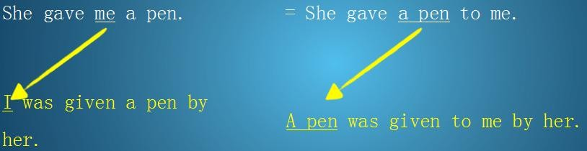



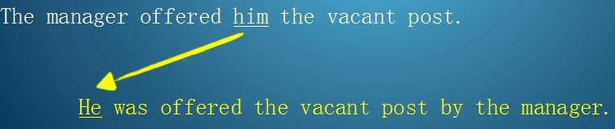

本课重点:

复习被动语态

双宾语的被动语态

